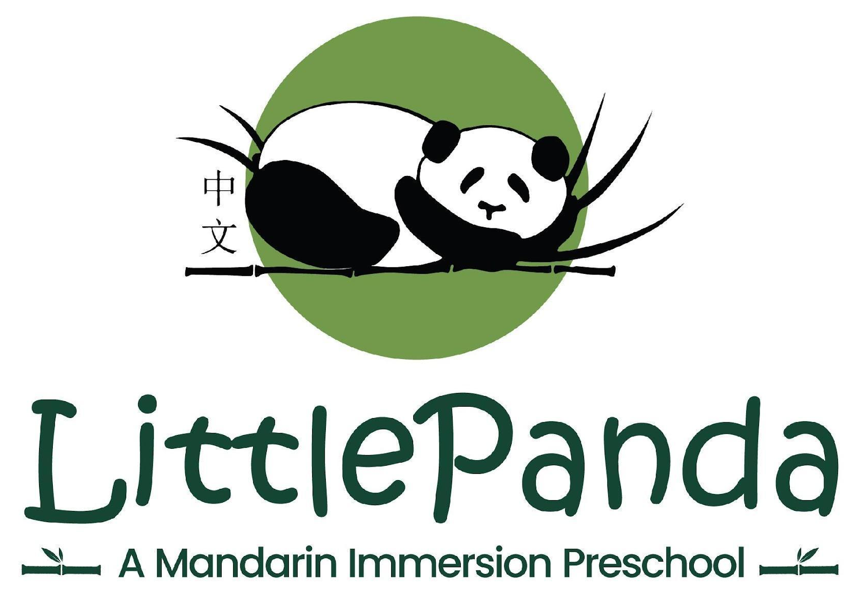

2026-2076 Little Panda Registration Form
Wed Aug 26, 2026 – Fri May 28, 2027
8:30 AM – 12:30 PM

Child’s Name ______________________ Chinese Name ______________________

Birth Date _________________________ Age ___________ Sex M F non-binary

Allergies ___________________________________________________________________

Home address: ______________________________________________________________

Street City State Zip

Home Phone: _____________________________

1st Guardian's Name: ______________________________ Relationship: _______________

Cell Phone: ______________________Work Phone: _______________________
Email: ___________________________________

2nd Guardian's Name: ______________________________Relationship: _______________

Cell Phone: ______________________Work Phone: _______________________

Email: ___________________________________

Health Care Provider & Phone __________________________________________________

Please circle: my child wears a diaper is potty training is potty trained

Emergency Contact Name & Phone if unable to contact parents:

___________________________________________________________________________
Persons authorized to pick up your child from school:

___________________________________________________________________________

Where did you learn about Little Panda? __________________________________________

Days of Attendance & Registration Fees (Please check and/or circle days)
Days Per Week | □ 5 days | □ 4 days | □ 3 days | □ 2 days
Days of Attendance | Mon - Fri | Mon Tue Wed Thu Fri

REGISTRATION – A child should reach the age of two upon enrollment. To secure a spot for your child, please submit this registration form and a check for a registration fee of $60 per student. For new students, please add a one-time new student enrollment fee $199/student. Both registration fee and new student enrollment fee are non-refundable once the registration is confirmed. Please make the check payable to Little Panda Mandarin Preschool (LPMP) or pay through Venmo @littlepandamandarinpreschool.

2026-2027 TUITION & FEES
Enrollment Fee | $199/one time
Application/Registration Fee | $60/year
Monthly Tuition | 5 mornings | $780/month
Monthly Tuition | 4 mornings | $640/month
Monthly Tuition | 3 mornings | $500/month
Monthly Tuition | 2 mornings | $350/month
Others | Late Pickup Fee (after 12:30 PM) | $1/minute
Others | Tuition Late Payment Fee | $ 25

PERMISSION & LIABILITY WAIVER
Being the lawful parent(s)/guardian(s) of _______________________, I hereby consent to the participation of said child in all LPMP activities. I further authorize LPMP staff to provide, approve, and authorize necessary health care at any health institution; employ any health care service worker whose services may be needed for health care; review and if necessary disclose the contents of any medical records; and execute any consent form required by health authorities incident to the necessary provision of medical, surgical, or dental care to the child. I further authorize emergency transportation by either LPMP personnel, ambulance, or other emergency vehicle. If there is no medical emergency, LPMP staff will first use reasonable efforts to contact the parent(s)/guardian(s) before administering or authorizing any treatment. LPMP is well child-proofed and the students are consistently well-supervised. However, accidents do happen. The undersigned assume all risk of injury or harm to the child associated with participation in LPMP and agree to release, indemnify, defend, and forever discharge LPMP and its staff and agents from all liability, claims, demands, damages, costs, expenses, actions, and causes of action in respect of injury, loss, death or damage to the child, or by the child, howsoever caused, to arise by reason of or during the child’s participation in LPMP.

I have read this registration form and the Little Panda Parent Handbook and agree to abide by all school policies.

Guardian Signature: ___________________________________ Date: ______________

For more information contact: Director Gawin Tsai at 919-666-7363 or durhamlittlepanda@gmail.com

