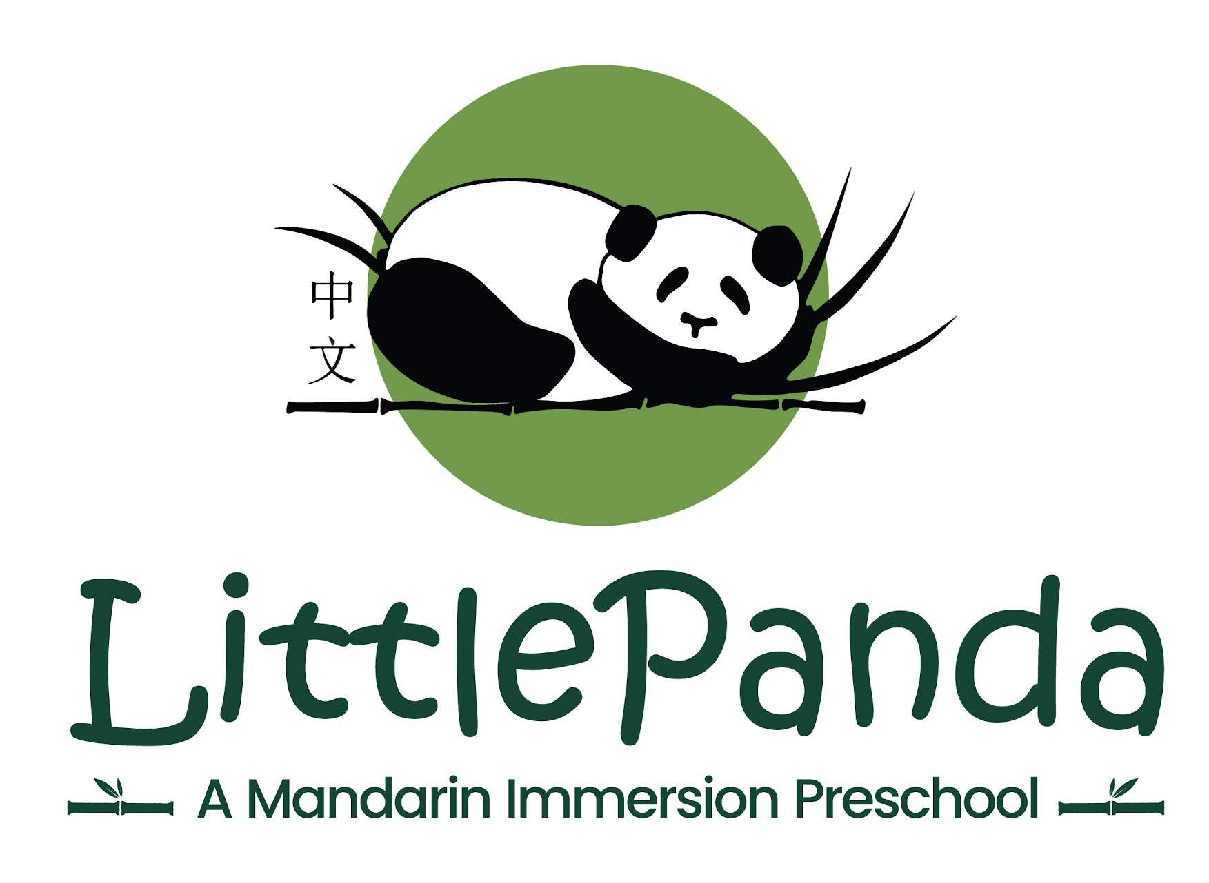

中 文 夏 令 营2026 Little Panda Summer Camp Registration Form
June 8-26, August 3-21, 2026 (6 weeks)
8:30 AM – 12:30 PM

Student Name: __________________________ Birthday: ___________ Age: _____ Sex: ______

Allergies: _______________________________________________________________________

Home address: __________________________________________________________________

Street City State Zip

Home Phone: _____________________________

Guardian #1 Name: _____________________________________ Cell: _____________________

Work Phone: _______________________ Email: _______________________________________

Guardian #2 Name: ____________________________________ Cell: ______________________

Work Phone: _______________________ Email: _______________________________________

Emergency contact name & phone if unable to contact parents:

____________________________________________________________________________

Persons authorized to pick up your child other than listed guardians:

_____________________________________________________________________________

Tuition: $195/week ($39/day) for 8:30am-12:30pm. Snacks will be provided. Please send lunch with your child. There are 13 spots per day, first come, first served. A $100 deposit (which will be credited to your total tuition due) is due when you register for the camp. Total amount of camp tuition is due by April 1st. If you register after April 1st, total camp tuition is due upon registration. A $50 discount will be applied to those who register for all 6 weeks, 5 days a week. We reserve the right to cancel certain weeks of camp if not enough children are registered.

Cancellation/Change Policy:
You may cancel/change your camp registration up to April 1st. After April 1st, we will not be able to accommodate any refunds or exchanges. To cancel or change your registration, please send an email to durhamlittlepanda@gmail.com.

Please mark the weeks/days that you would like to register for (minimum 2 days a week)
Week | Dates | Theme | Days
1 | June 8-12 | Outdoor Activities | M Tu W Th F
2 | June 15-19 | In the Orchard | M Tu W Th F
3 | June 22-26 | Rainforest Animals | M Tu W Th F
4 | August 3-7 | Craft Supplies | M Tu W Th F
5 | August 10-14 | Snacks | M Tu W Th F
6 | August 17-21 | Desert Animals | M Tu W Th F

I have read this registration form and agree to the Cancellation/Change Policy.

Parent Signature: ___________________________________ Date: _____________________

Notice of Nondiscrimination Policy as to Students
LPMP admits students of any race, color, national and ethnic origin to all the rights, privileges, and activities generally accorded or made available to students at the school. It does not discriminate on the basis of any race, color, national and ethnic origin in administration of its educational policies or other school-administered programs.

For more information please email durhamlittlepanda@gmail.com.
Updated on 1/2026

